2016 Hannah’s House ministries, inc

2016 Hannah’s House Program Participants
Your generosity has provided Housing and Utilities, Furniture, Food and Supplies, Transportation and Life and Discipleship training for:
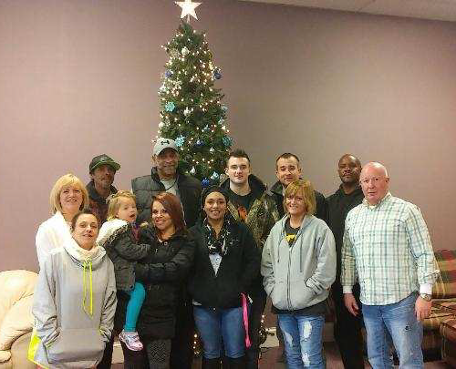
81 total residents in 2016
23 Men
37 Women
21 Children
Monthly Average Utilities: $2660.00
Monthly Transportation Average: $400.00
Monthly Food and Supplies Average: $850.00
Monthly Maintenance on Homes: $400.00
Monthly Insurance, Payroll and other expenses: $1250.00
Here we are with some of our Hannah’s House family (maximum residents at one time is 36).
Of our residents: 16 started working; 4 studying for GED; 5 enrolled in classes at Independence Community College; 7 completed work and life preparation classes (Circles, Bridges).
Please visit our website for a short video of lives that have been touched by your faithful giving at www.hannahshouseks.com
Ministry needs and desires:
Increased monthly giving for expenses and to hire evening and weekend staff. Targeting additional $1000 in monthly pledges for personnel.
Trailer and hitch for donation pick up, to move residents and renovate houses and new buildings.
IT Technology Volunteer – camera/security systems, computer systems, website
Dumpster to begin renovation (demo) on 1 house and 2 buildings.
Our vehicles are older (and so blessed by these donations) which provide transportation for residents to get to appointments and to work but a desire is for a 12-passenger van or additional good used vehicles to be used in the ministry would be gladly received.
Current needs for the residents – 2 complete Baby Beds and bedding (twin girls); 4 chests of drawers; 1 set of bunk beds and mattresses; Flatware set for 16
We can always use food, good used furnishings, appliances, dishes, pots and pans, pillows, blankets, towels and paper supplies. When our residents move to their own homes, it is such a blessing to be able to help them set up their homes with your generosity. Please bring all donations to the Crystalbrook Church office and not directly to one of the houses unless instructed to go there. We have donation receipts available for you and we will find the best place for your donation to be used.

