2017 Hannah’s House ministries, inc

2017 Hannah’s House Program Participants
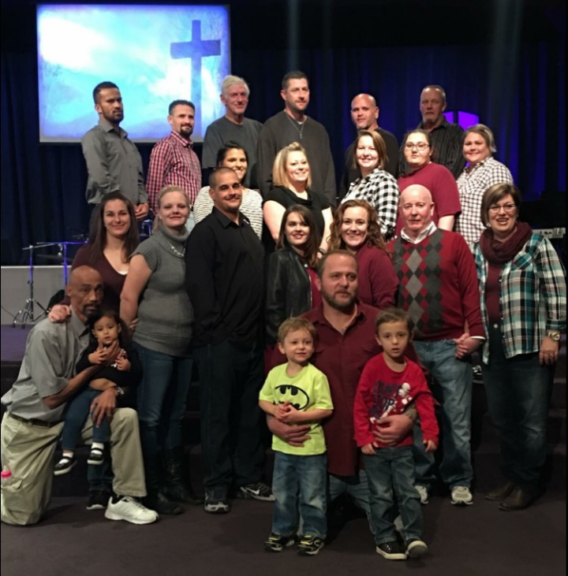
Your generosity has provided Housing and Utilities, Furniture, Food and Supplies, Transportation and Life Empowerment and Discipleship training for: 81 total residents in 2017
41 Men
29 Women
11 Children
By state - 50 Residents from Kansas; 31 Residents from Oklahoma; 2 from Missouri; 1 from Arkansas and 1 returned home to Louisiana.
Of our residents: 24 started working; 4 are working on High School Diplomas; All adults as residents are engaged in Hannah’s House program. Many have also been participants in Momentum, another program offered by our community that helps prepare them for work.
Hannah’s House program asks for a 6-month commitment and are required to complete 6 contracts as participants to graduate before they begin working. This training time transforms their life and gives them tools for success. Each contract they must complete summaries of required bible study, memorization of Bible verses, Character trait studies, and one book read with each contract along with a work zone chores and projects each day.
Here are some Average Monthly Expenses that your contribution provides:
Utilities: $2700.00 Transportation: $450.00
Food and Supplies: $850.00 Maintenance on Homes: $400.00
Insurance, Payroll and other expenses: $1400.00 Training Materials: $200.00
Ministry needs and desires:
Youth Center – Funds to start the renovation - $1500 for the electric and water.
Roofing Supplies for additional house.
Truck, Trailer and Hitch for donation pick up, to move residents and renovate houses and buildings.
We can always use food, personal care items, pillows, towels and paper supplies.
Your In-Kind giving of good used furnishings, appliances, dishes, pots and pans, blankets are a blessing as our residents move to their own homes. Your generosity helps them set up their homes as they start working. We also have been able to help others in the community with any extra items that have come into the ministry.
Please bring all donations to the Crystalbrook Church office and not directly to one of the houses unless instructed to go there. We have donation receipts available for you and we will find the best place for your donation to be used.
All monetary donations can be addressed to:
Hannah’s House Ministries, Inc
PO Box 176
Independence, KS 67301
Online Donation can be made at www.hannahshouseks.com

