2018 Hannah’s House ministries, inc.

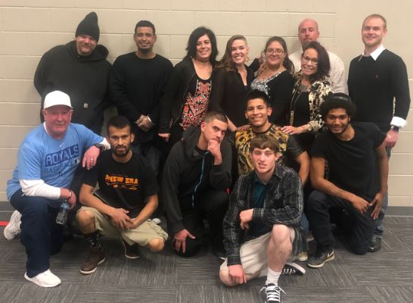
2018 Hannah’s House Program Participants
Your generosity has provided Housing and Utilities, Furniture, Food and Supplies, Transportation and Life Empowerment and Discipleship training and Staff for:
92 total residents in 2018
41 Men
39 Women
12 Children
By state - 66 from Kansas; 21 from Oklahoma; 2 from Missouri; 1 from Nebraska and 2 from Texas. Hannah’s House program asks for a 6-month commitment and are required to complete 6 contracts as participants to graduate before they begin working. This training time transforms their life and gives them tools for success. Each contract they must complete summaries of required bible study, memorization of Bible verses, Character trait studies, and one book read with each contract along with a work zone chores and projects each day.
Here are some 2018 Average Monthly Expenses that your contribution provided:
Utilities: $3146.00 Transportation: $450.00 Insurance, Payroll and other expenses: $2200.00
Food and Supplies: $1558.00 Maintenance on Homes: $1282.00 Training Materials: $200.00

You can meet some of our graduates by viewing the Testimony Videos Online on the YouTube Crystalbrook Church Channel and go to the playlist. https://www.youtube.com/channel/UCkAQMTbS9h762ownPtMcjOQ/playlists
2018 Completed Building items:
Completed new roof on the Grace House – Re-Integration Housing for our Women Graduates Roof Repairs on Apartments from flooding in June – Re-Integration Housing Appliances Replaced – Hot Water Heater (damage from the flooding in June), Refrigerator, 2 Stoves and a Washer. Storage Garage Overhead Door replaced to allow it to be locked with supplies. Youth Center – Electric is on, Water will be on when plumbing is repaired, and we are still working on the gas. Renovations started on a newly donated home which is being used for a family. Carpets were removed and replaced, painting and new toilet installed.
2019 Ministry needs and desires:
Staff Payroll & Benefits – Our helpers are one of our greatest assets! We have been blessed so many times with people who see the work they do at Hannah’s House as a calling and more times they could easily go to a local job and make more money. This work is like the work of a missionary but local and 24/7. We want to be excellent in the care of our staff- without them we could not have the care needed for rebuilding lives. Youth Center – We are currently working on plumbing repairs for the water and getting the gas on so there will be heat. Next steps will be to get a renovation design and building permit. Roof Repairs - We have multiple roofs which need to be replaced or patched. Single Parent homes – We are in the process of rebuilding the back porch of one home which has a single mom and 3 children and we are working on plumbing repairs on another single mom and her 2 children.
We can always use food, personal care items, pillows, towels, socks and paper supplies.
All monetary donations can be addressed to: Hannah’s House Ministries, Inc.
PO Box 176
Independence, KS 67301
Online Donations can be made at www.hannahshouseks.com

