2019 Hannah’s House ministries, inc.

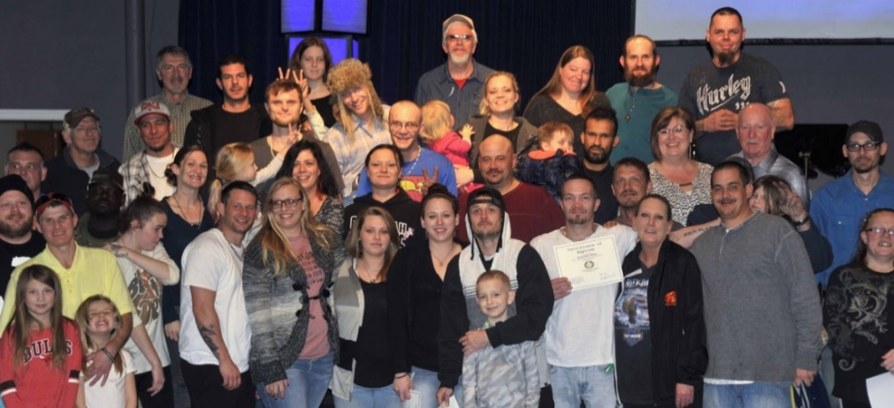
Your generosity has provided Housing and Utilities, Furniture, Food and Supplies, Transportation and Life Empowerment and Discipleship training and Staff for:
94 total residents in 2019
42 Men
42 Women
9 Children
Hannah’s House program asks for a 6-month commitment and are required to complete 6 contracts as participants to graduate. This training time transforms their life and gives them tools for success. Each contract they must complete summaries of required Bible study, memorization of Bible verses, Character trait studies, and one book read with each contract along with work zone chores and projects each day.
Below are some 2019 Average Monthly Expenses that your contribution provided:
Utilities: $3422.00 Transportation: $606.00 Insurance, Payroll and other expenses: $3031.00
Food and Supplies: $1235.00 Maintenance on Homes: $1725.00

You can meet some of our graduates by viewing the Testimony Videos Online on the YouTube Crystalbrook Church Channel and go to the playlist. https://www.youtube.com/channel/UCkAQMTbS9h762ownPtMcjOQ/playlists
Join us for Hannah’s House Chapel which is streamed live on Facebook @HannahsHouseks at 9 am and 1 pm Tuesday-Friday
Coming Soon – www.soundcloud.com podcast - Best Blessed Life Ever – Drumeller Life Adventure
2019 Completed Building items:
Completed new roof on the Penn House – Re-Integration Housing for our single parent graduates. Completed new roof on the newly donated men’s house. Bathroom foundation, floor and toilet replacement & new tile backsplash and paint in kitchen on single parent graduate home.
2020 Ministry needs and desires:
Volunteer Opportunities – Transportation Coordinator and Drivers, Food Coordinator, Class monitors and devotion reviewer – would be a great place for a retired teacher, and Life Coaches
Building Projects- Raise funds to replace apartment heater for re-integration housing, Paint interior of several apartments, Rebuild porches of our single parent Penn home, another single parent home roof replacement

We can always use food, personal care items, pillows, towels, socks and paper supplies.
All monetary donations can be addressed to: Hannah’s House Ministries, Inc.
PO Box 176
Independence, KS 67301
Online Donations can be made at www.hannahshouseks.com
Text-to-Give enter the number 73256 and text Hannah

